Title: Optimizing a Meal Plan for Nutritional Balance using

Non-Linear Programming

Project Report – Python implementation and explanation of simplex method by Pratheeksha Sumesh

Contents
Title: Optimizing a Meal Plan for Nutritional Balance using 1
Non-Linear Programming 1
Project Report 1
Problem Statement 2
Theoretical Formulation (Model) 2
Objective: 2
Decision Variables: 2
Objective Function: 2
Subject to Constraints: 2
Methodology: 3
Implementation Details 7
Tools & Libraries: 7
Data Inputs: 7
Sample Considered: 7
Implemented: 9
Insights: 17
Limitations and Future Work 17
Ensuring meal count constraints alongside nutrition thresholds required careful constraint 17
formulation. Dealing with fractional meal portions may not be practical; integer programming would be more realistic but computationally heavier. 17
Input data variability: real nutritional values can differ; data cleaning was important. 17
Balancing user modifications to meal costs or deletions while maintaining solution 17
feasibility 17
Conclusion 17
• The project successfully models weekly meal planning as a linear optimization problem, efficiently balancing cost and nutrition. Using Python and SciPy’s linprog, the solution generates practical meal plans that can assist in institutional food planning or personalized diet design. 17

Problem Statement
Planning a nutritious weekly meal plan within a budget is a common challenge, especially for institutions like hostels or cafeterias. The goal is to select meals that meet minimum daily nutritional requirements (calories, protein, and carbohydrates) while minimizing the overall cost. This project focuses on optimizing a 7-day meal plan for breakfast, lunch, and dinner from a set of available dishes, enriched with add-ons, to achieve balanced nutrition at the lowest possible cost. 2. Theoretical Formulation

Theoretical Formulation (Model)

Objective:
Minimize the total cost of meals over a 7-day week.

Decision Variables:
Let x_{i} be the binary decision variable indicating the selection of the i^{th} meal (1 if selected, 0 otherwise).

Objective Function:
Minimize:

n
∑ c_{i}x_{i}
i=1

Where c_{i} is the cost of meal i

Subject to Constraints:

Nutritional Constraints (for each meal type):
n
∑ cal_{i}x_{i} ≥ C_{min}
i=1
n
∑ prot_{i}x_{i} ≥ P_{min}
i=1 n
∑ carb_{i}x_{i} ≥ CB_{min}
i=1
Meal Count Constraint:
n
∑ x_{i} = 7
i=1

Bounds on Decision Variables:

x_{i} ∈ [0, 1] (relaxed binary for LP solver)
This means that each of x_{i} variables can take 0 (when that particular dish is not chosen) and 1 (when that particular dish is chosen).In the end 7 such dishes will be chosen for each meal.

Methodology:

- Linear programming is used via scipy.optimize.linprog
- Constraints are formulated to model nutrient intake requirements Meals are optimized separately for breakfast, lunch, and dinner
- Nutritional add-ons are included to enrich certain meals
- After getting the optimal solution the user is given the options of how they want to modify the code.
- Namely, to remove a dish or edit the cost.
- Then after making these changes the problem is optimized using the above methods again.
- The second time after modifying corresponding to the users option this dish after modifying will be added to all the other dishes to understand weather it is part of the optimum solution .

Methods used by scipy.optimize.linprog

This python library is the key to implementing optimization technique.
It uses a ‘highs’ method which carries out the following methods
Methods that are used in the code:

What is Primal Simplex Method?
The primal simplex method is an algorithm that starts with a feasible solution (one that satisfies all the constraints) and then moves step by step to reduce cost (or increase profit), eventually reaching the best solutions.

Why do we use Primal Simplex Method?

We use the Primal Simplex method because it helps us find the best solution to a linear programming problem, such as: Choosing the best combination of meals that gives enough nutrition at the lowest cost.

What it does?
- Starts with a solution that meets all the rules (e.g., enough calories, protein, carbs).
Tries to make the cost lower while still following all those rules.
- Moves step by step to find a better and better solution.
- Stops when it can’t do any better.

What is Dual Simplex Method?
The dual simplex method is an iterative algorithm that starts with an optimal but infeasible solution and move towards a feasible solution while maintaining the optimality with respect to the dual problem. It is used when changes in a linear program (like removing a constraint or modifying a cost) make the current solution infeasible.

Why do we use Dual Simpex Method?
- Quick Fix After Changes: When a problem changes slightly (like modifying a constraint or removing a variable), instead of solving the whole thing again from scratch, dual simplex helps adjust the current solution efficiently.
- Infeasibility but Optimal Objective: Sometimes we have a solution that gives the best cost/profit, but it breaks some rules (like budget or nutritional constraints). Dual simplex helps fix the rules while keeping the cost optimal.
- Useful in Sensitivity Analysis: In real-world applications (like supply chains or diet plans), dual simplex helps when inputs change dynamically, allowing quick re-optimization.
- Good for Integer Programming Relaxations: It’s also used in branch and bound methods, where many LP relaxations are solved one after another — dual simplex helps solve these faster if previous solutions are reused.

What it does?
- Starts with an optimal but infeasible solution: (You have the best possible value for the objective function, like lowest cost, but you’re breaking some rules or constraints.)
- Fixes the broken rules (i.e., makes the solution feasible).
It step-by-step adjusts the solution so that all constraints are satisfied.
- Keeps the cost (or objective) as low as possible
while fixing the constraints, it tries not to increase the total cost (or reduce profit).
What is Interior Point Method?
The Interior Point Method finds the optimal solution of a problem by starting inside the feasible region (not on the boundary) and moving through the interior toward the best solution.

Why do we use Interior Point Method?
- Solving large linear programs
- Handling sparse problems efficiently
- Providing numerical stability in some cases

What it does?
- Starts inside the region of possible solutions (called the feasible region”).
- Moves through the inside of the region (not on the boundary like the Simplex method).
- At each step, it finds a direction and distance to move that improves the objective (like minimizing cost or maximizing profit).
- It keeps updating the solution until it reaches the best (called the optimal solution).
- It stops when no better solution is possible inside the region.

What is Post Optimality Analysis?
Post-optimality analysis, or sensitivity analysis, is the examination of the change in the optimal solution of an optimization problem due to small perturbations in:
- Objectivefunction coefficients (for example, unit cost or profit)
- Values of constraints on the right-hand side (e.g., resources available).
- Constraint coefficients (e.g., activities utilization of resources).

Why do we use Post Optimality Analysis?
- Saves Time and Effort:
Small changes are not required to re-solve the whole model analysis tells you if the current solution is still optimal.
- Tests Solution Stability:
It tells you how sensitive your optimum solution is to cost changes, resource changes, or constraint changes.
- Helps in Decision-Making:
Helps in allocating resources and verifying what occurs under "what-if" scenarios (e.g., increase in budget, variations in prices).
- Unveils Critical Constraints:
Tells you what of the limits are the closest and how they can be relaxed with minimal consequence.
- 5. Improves Planning in Uncertainty:
Is appropriate where input values are not specified or are free to alter with real-life variations (like rates or amounts).

What it does?
- Checks if the current solution stays optimal after a change.
- Indicates how the objective value (for example, cost or profit) varies.
- Identifies the range within which inputs can vary without affecting the solution.
- Reveals which constraints are tight (binding) and which have room to adjust.
- Assists in making instant decisions without redoing the problem from scratch.

Implementation Details

Tools & Libraries:
- Python: programming language used for implementation.
- NumPy: for efficient numerical array handling.
- Pandas: for tabular representation of results.
- SciPy's optimize.linprog: solver for the linear programming problem, using the HiGHS algorithm.

Data Inputs:

Sample Considered:

Breakfast options:
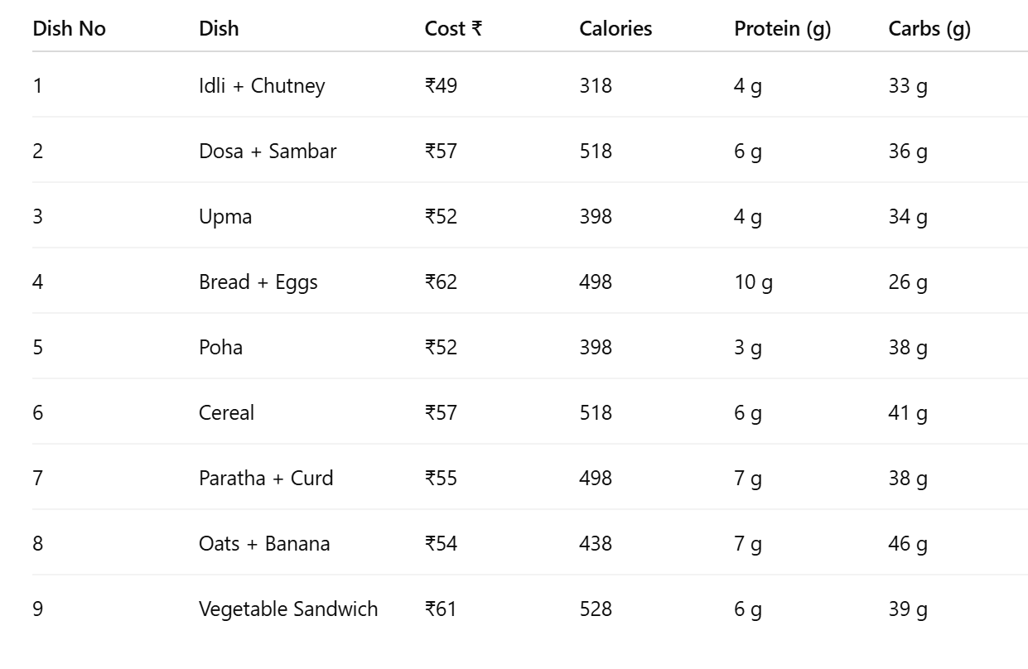
Lunch options:
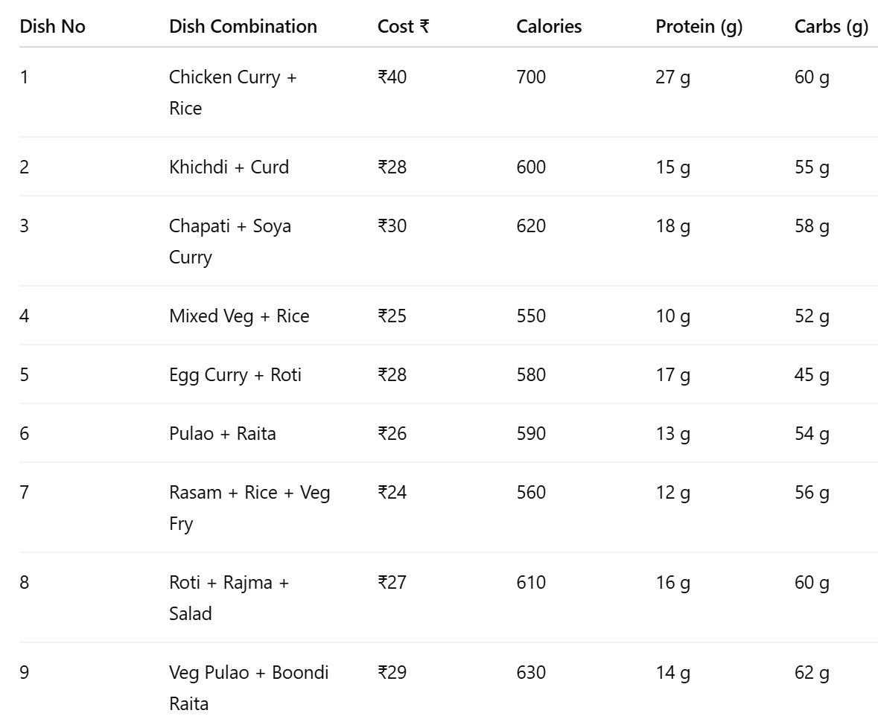
Dinner options: 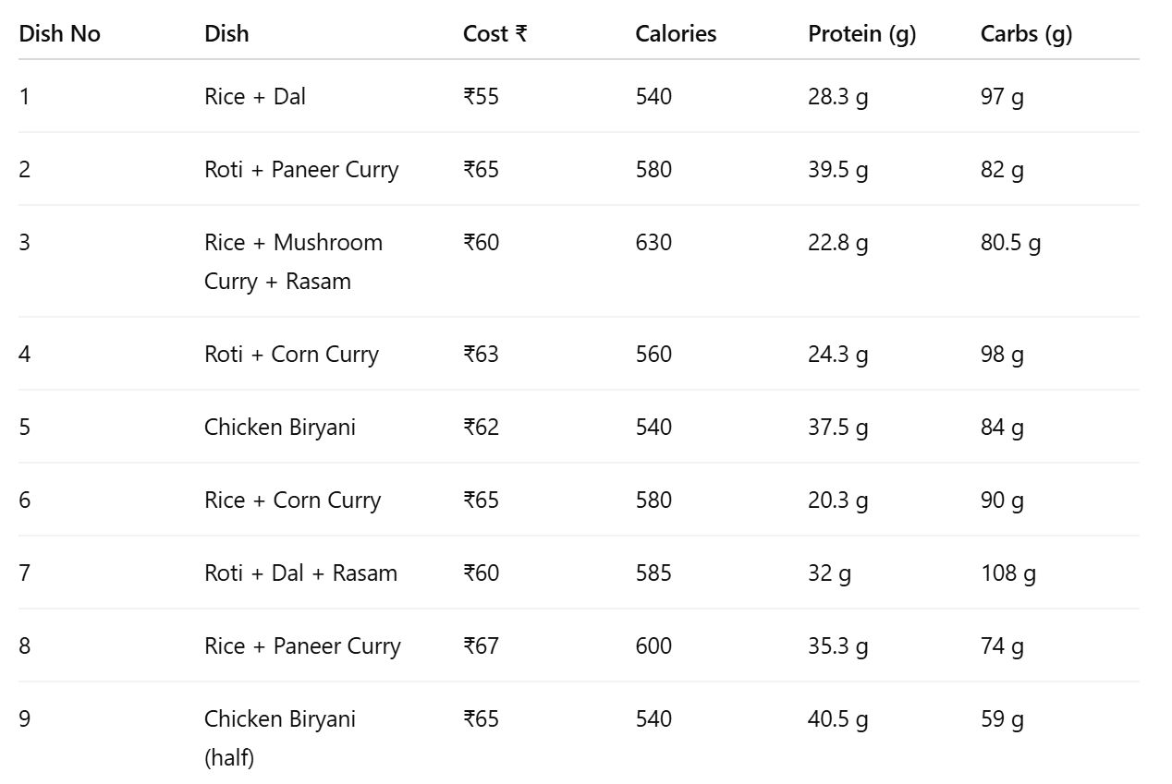

Note:This meal otptions consider one serving and considers only for one person right now.Also this does not include the nutritional addons that is added after

Implemented:

- Enriched meals with additional nutrition
- Optimization function for each meal type
- Nutrient and cost summary table

Code snippets (Key to applying optimization in the problem) explanation :

- Libraries
- scipy.optimize.linprog: For linear programming optimization
- numpy (as np): For efficient array operations

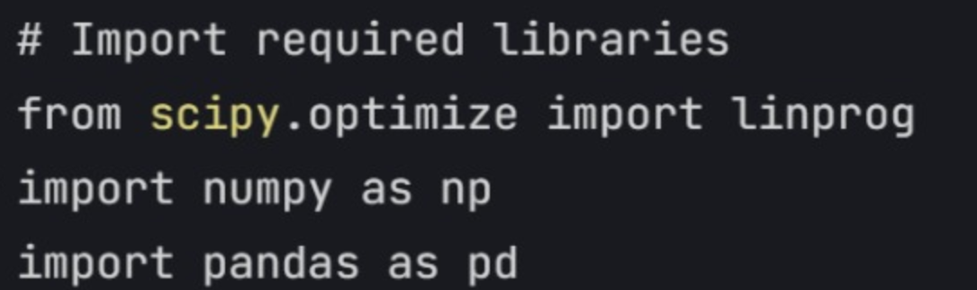
- Input sample data and storage(breakfast shown)
- The cost ,calories , protein and carbohydrates stored one by one respectively for each breakfast option .(similarly done for lunch and dinner)

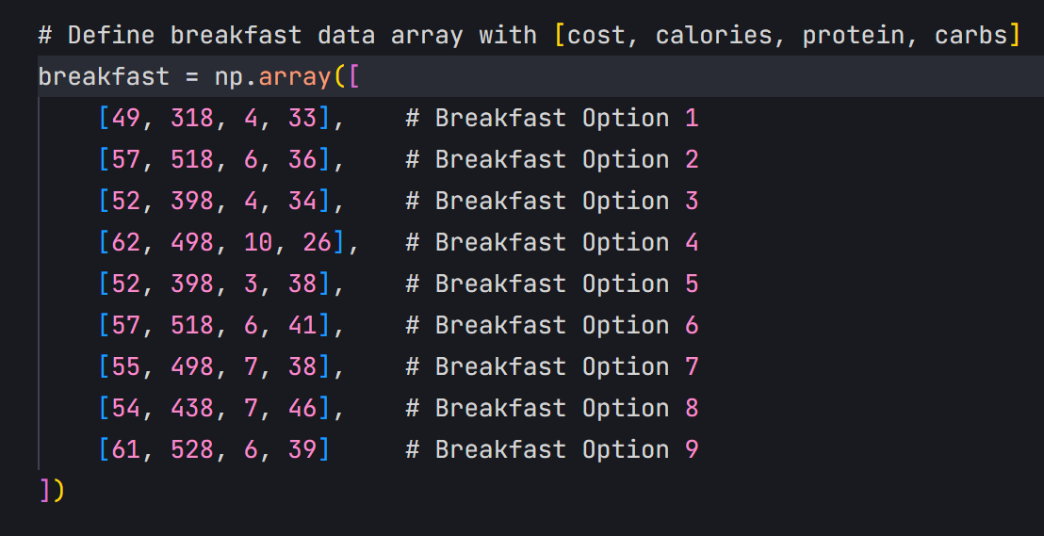

- Nutritional addons :
- A few items were added to every breakfast and dinner option so that a combination of 7 options could potentially satisfy the nutritional constraints.
- Without these the code would run into an error.
- For breakfast we have taken the example of milk + eggs+fruit
- For dinner we have taken the example dal+curd+mixed salad.

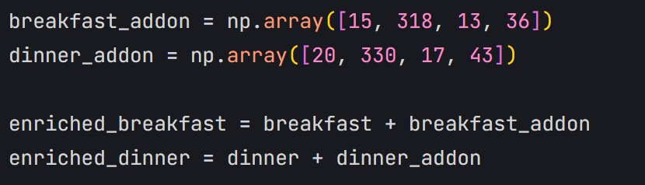

- This the main function that gives us the optimal solution(in this case minimizing)
- The function the data that we have put into arrays before and the requirements of the nutritional constraints and then the objective function and corresponding constraint matrix is created.
- It is also instructed to select only 7 meals
- After carrying out the minimization the variables are assigned 1/0(binary)based on if that meal option for that particular meal option is chosen or not.
- The linprog library carries out a method called “highs”.The specific optimization techniques that are used in it ar already explained above .

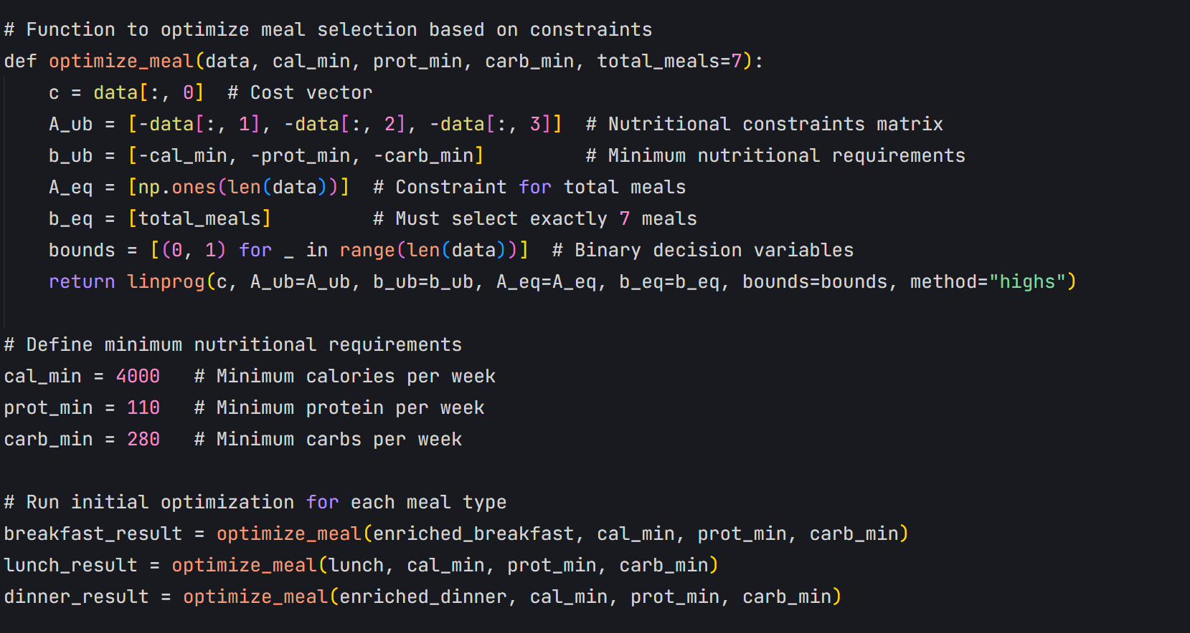

- Padding of meal lists:
- If optimization succeeded:
- Creates list of chosen meals (where x > 0.1 in optimization result)
- Pads the list with "(extra)" meals if needed to reach 7 meals
- If optimization failed:Returns list of 7 "FAILED" messages
- Finally this succeeded result is stored in organized way into a data frame.

Note: here the result shows that to be chosen the variable should have been assigned a value more than 0.1 and not 1 as discussed before but here optimization uses relaxed binary variables .So sometimes the answer might be 1 but the output might show 0.999.Therefore the condition is relaxed to accommodate it.

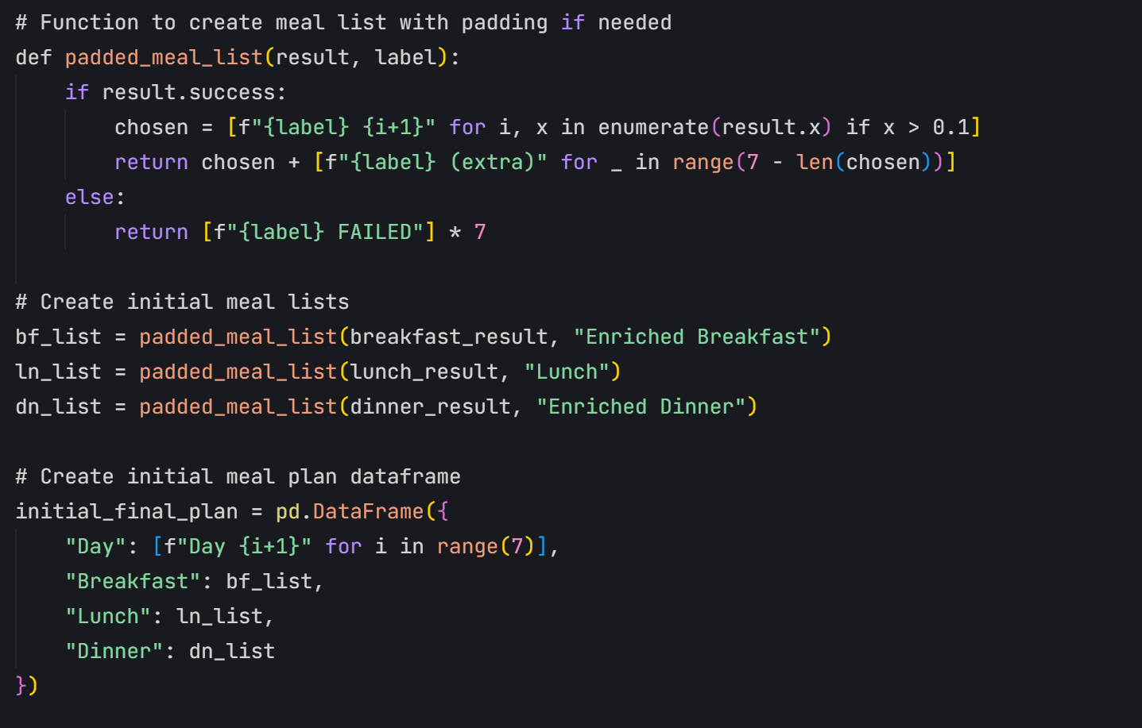

- Computing totals
- Total cost, calories, protein, and carbs for each meal type.Grand totals across all meals are found to be displayed.Then:
- Column "Meal": Lists meal types and total
- Column "Cost (₹)":
-Index 0 of each total array (initial_tot_bf[0], etc.)
- Sums all costs for total
- Column "Calories":
- Index 1 of each total array
- Sums all calories for total
- Similarly for protein and carbohydrates.

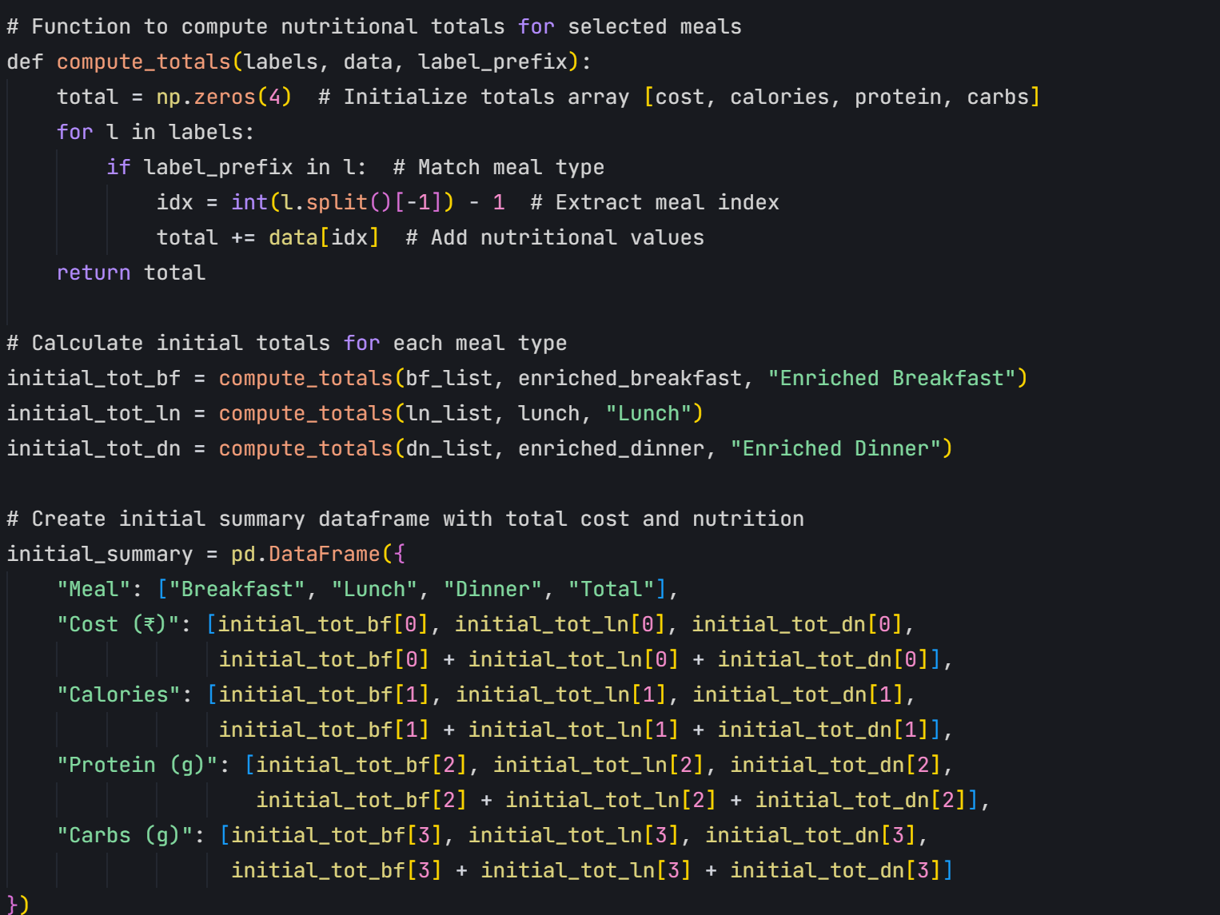

- Modifications after finding the optimal solution.(to accommodate ban of a certain meal option or fluctuating prices)
- Provides two modification options:
- Edit: Changes the cost of a meal
- Delete: Removes a meal from options
- For cost editing:
- Subtracts addon cost to get base cost
- Updates the cost in the enriched_breakfast array
- - For deletion:
- Uses numpy's delete function
- Removes the meal from the array entirely
- This loop runs on till the user decides to stop modification.

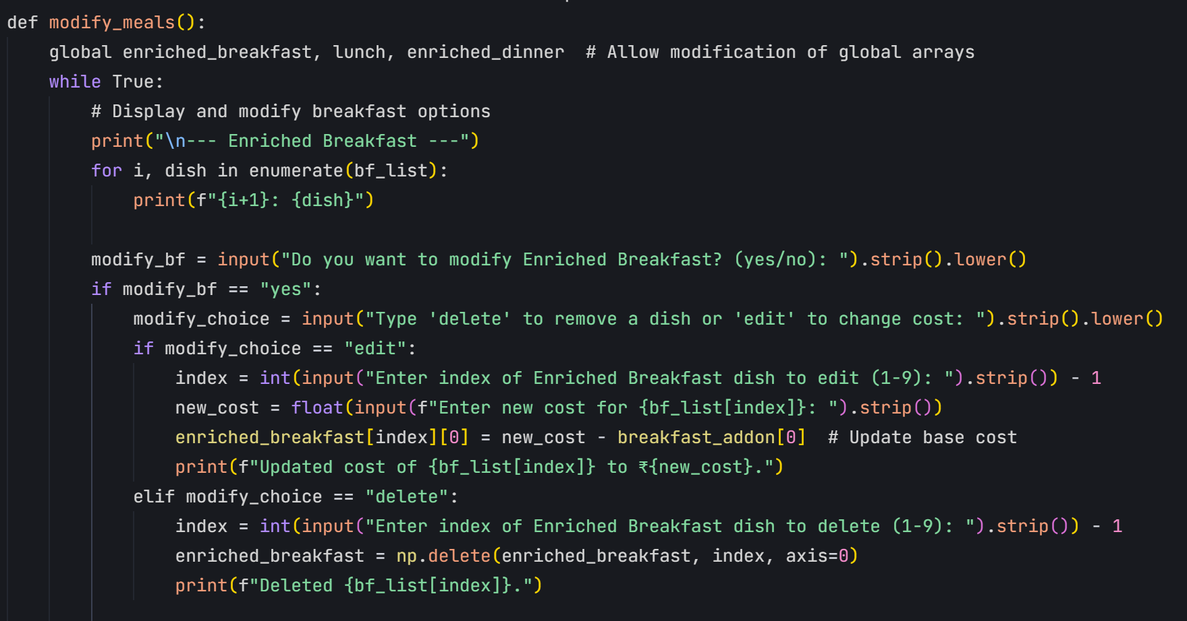

- After modifications carries out optimization again:
- After modifications it calls all the functions again to get a new optimized meal plan.(carried out in the exact same way as before.

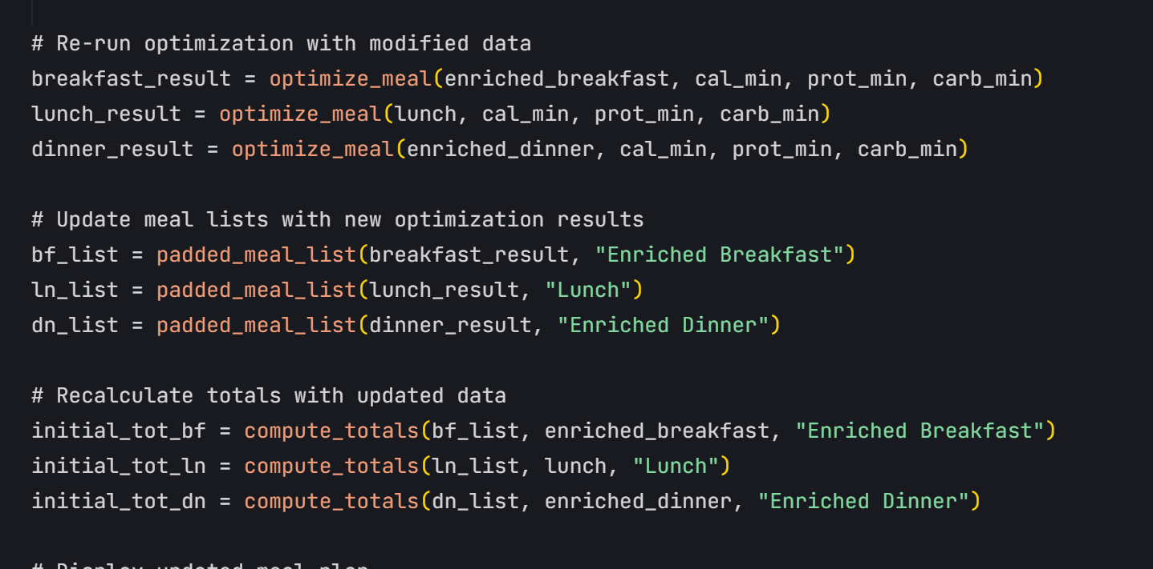

- The cost is calculated for the total number of students:
- Takes number of students as input
- Calculates per-student cost from our optimized meal plan
- Multiplies by number of students
- Creates a summary showing both per-student and total costs
- After the meal modification process:
- Asks for number of students
- Calls the function to calculate total cost
- Displays the results in a table

The whole code :

- Results:
- PS D:\workspaces\workspace_python\python_app> & 'd:\workspaces\workspace_python\python_app\venv\Scripts\python.exe' 'c:\Users\sumes\.trae\extensions\ms-python.debugpy-2025.6.0-win32-x64\bundled\libs\debugpy\launcher' '64462' '--' 'D:\workspaces\workspace_python\python_app\test\Opt_prj2.py'

- Initial Meal Plan:
- Day Breakfast Lunch Dinner
- 0 Day 1 Enriched Breakfast 2 Lunch 1 Enriched Dinner 1
- 1 Day 2 Enriched Breakfast 4 Lunch 2 Enriched Dinner 2
- 2 Day 3 Enriched Breakfast 5 Lunch 3 Enriched Dinner 3
- 3 Day 4 Enriched Breakfast 6 Lunch 4 Enriched Dinner 4
- 4 Day 5 Enriched Breakfast 7 Lunch 5 Enriched Dinner 5
- 5 Day 6 Enriched Breakfast 8 Lunch 6 Enriched Dinner 6
- 6 Day 7 Enriched Breakfast 9 Lunch 7 Enriched Dinner 7

- Initial Nutritional Summary:
- Meal Cost (₹) Calories Protein (g) Carbs (g)
- 0 Breakfast 242.0 4006.0 134.0 474.0
- 1 Lunch 201.0 4200.0 112.0 380.0
- 2 Dinner 430.0 5635.0 256.7 798.5
- 3 Total 873.0 13841.0 502.7 1652.5

- --- Enriched Breakfast ---
- 1: Enriched Breakfast 2
- 2: Enriched Breakfast 4
- 3: Enriched Breakfast 5
- 4: Enriched Breakfast 6
- 5: Enriched Breakfast 7
- 6: Enriched Breakfast 8
- 7: Enriched Breakfast 9
- Do you want to modify Enriched Breakfast? (yes/no): no

- --- Lunch ---
- 1: Lunch 1
- 2: Lunch 2
- 3: Lunch 3
- 4: Lunch 4
- 5: Lunch 5
- 6: Lunch 6
- 7: Lunch 7
- Do you want to modify Lunch? (yes/no): yes
- Type 'delete' to remove a dish or 'edit' to change cost: delete
- Enter index of Lunch dish to delete (1-9): 3
- Deleted Lunch 3.

- --- Enriched Dinner ---
- 1: Enriched Dinner 1
- 2: Enriched Dinner 2
- 3: Enriched Dinner 3
- 4: Enriched Dinner 4
- 5: Enriched Dinner 5
- 6: Enriched Dinner 6
- 7: Enriched Dinner 7
- Do you want to modify Enriched Dinner? (yes/no): no

- Do you want to make more modifications? (yes/no): no

- Enter the total number of students: 300

- Total Cost Summary:
- Category Cost (₹) Students
- 0 Per Student 873.0 1
- 1 All Students 261900.0 300

- Total cost for 300 students: ₹261900.00

Insights:

Nutritional targets are met within a budget
The system is ﬂexible to adapt to real-world changes
Costlier dishes are deprioritized unless nutritionally dense
Trade-offs between nutrient density and cost are clearly observable

Limitations and Future Work

Ensuring meal count constraints alongside nutrition thresholds required careful constraint

formulation. Dealing with fractional meal portions may not be practical; integer programming would be more realistic but computationally heavier.

Input data variability: real nutritional values can differ; data cleaning was important.

Balancing user modifications to meal costs or deletions while maintaining solution

feasibility

Conclusion

The project successfully models weekly meal planning as a linear optimization problem, efficiently balancing cost and nutrition. Using Python and SciPy’s linprog, the solution generates practical meal plans that can assist in institutional food planning or personalized diet design.
Done by:
Pratheeksha Sumesh(SE24UCAM040)
Gnanada Vanarparthi(SE24UCAM003)
Abhipsha Pujahari(SE24UCAM058)

